SD262A Aniline point tester for petroleum products
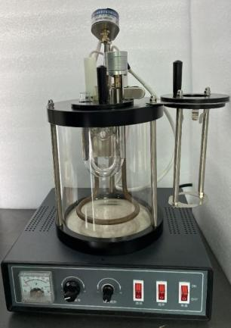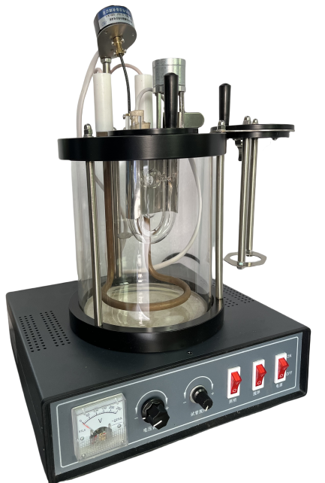
SD262A Aniline point tester for petroleum products is designed and manufactured according to the requirements stipulated in the national standard GB/T262 Aniline point tester for petroleum products. It is suitable for the determination of aniline point for light colored petroleum products and dark colored petroleum products.
The minimum temperature required for petroleum products and an equal volume of aniline to dissolve into a single liquid phase is called the aniline point.
Petroleum Products Aniline Point Tester
Aniline Point Tester of Petroleum Products and Hydrocarbon Solvents
ASTM D611 Aniline Point Tester
Laboratory GB/T262 Petroleum Products and Hydrocarbon Solvents Aniline Point Tester
Instrument Features
1. The design of the instrument fully conforms to the requirements of GB/ T262 standard for the aniline point test of dark petroleum products and light petroleum products.
2. The instrument can measure the aniline point of heavy oil (dark petroleum products) and light oil (light petroleum products).
3, Temperature control system adopts digital display PID temperature control instrument, high temperature control precision, stable and reliable performance, easy to operate.

Technical parameters:
Heating mode | Built in stainless steel electric heating tube for heating
Heating power | 2kW
Temp control range | RT ～ 200℃
Temp control accuracy | ≤0.5℃
Lighting power supply | 12V
Motor power | 6W
Working power supply | AC220V±10% 50Hz
Instrument size | 280*260*440 mm
Instrument weight | 5.45kg
Package size | 370*360*500 mm
Package weight | 13kg wooden
Note: The appearance pictures, dimensions, volume and weight of the instrument are for reference only. If there are any updates to the instrument, they may be slight changes without prior notice.
Packing list
No. | Name | Unit | Quantity | Remark
1 | Host | Set | 1
2 | Thermometer 25 ～ 105ºC, graduation 0.2℃ | Piece | 1
3 | Thermometer 90 ～ 170ºC, graduation 0.2 | Piece | 1
4 | U type tube (For heavy oil) | Piece | 1
5 | Metal shield (For heavy oil) | Piece | 1
6 | Illumination bulb assembly (For heavy oil) | Piece | 1
7 | Seat 2 for test device (For heavy oil) | Piece | 1 | With stirring motor assembly
8 | Glass test tube (For light oil) | Piece | 2 | Φ25
9 | Glass casing tube (For light oil) | Piece | 1 | Φ40
10 | Soft ring plug (for light oil testing) | Piece | 1 | Central hole Φ 25
11 | Test tube plug (for light oil testing) | Piece | 1 | Central hole Φ 9 and mixing rod hole
12 | Mixing rod (for light oil testing) | Root | 1
13 | Seat 1 for test device (For light oil) | Piece | 1
（1）Operation Manual 1 piece
（2）Repair Guarantee 1 piece
（3）Quality Certificate 1 piece

Shandong Shengtai Instrument Co., Ltd. provides the following quality assurance for the instruments sold to you:
----The provided instrument materials are brand new, meet national quality standards, and have a manufacturer's certificate of conformity;
----The materials and main components provided meet the technical requirements specified in the technical documentation;
----The overall quality assurance period of the equipment is one year (excluding normal wear and tear of vulnerable parts).
----We are responsible for free maintenance of any instrument quality issues that occur during the warranty period. Due to equipment malfunction caused by the user's responsibility, we are responsible for repairing and charging reasonable fees.
----Lifetime discounted supply of parts for equipment, and lifetime maintenance and repair of the entire machine.
----After the expiration of the warranty period, if the user needs maintenance and technical services, we will only charge a cost fee.

